SCSC is doing its part as a steward of our wetlands and watershed.  A lake's watershed is the area of surrounding land that channels rainfall and snowmelt via creeks, streams, rivers, ditches, storm drains and groundwater to the lake. Watersheds supply the water that replenishes our lakes, along with other elements critical to supporting life, such as nutrients and organic matter. Water moves through a never-ending loop from sky to land and back in various states of gas, liquid or solid through a process known as the water cycle. Undeveloped watersheds, such as the on | ﻿pictured above, help keep lakes and rivers clean by absorbing rainfall and keeping excess nutrients, such as phosphorus, out of the water.  We all live in a watershed. The health of our lakes and waterways is determined by what happens in their watersheds. SCSC has been stewards of our watersheds since 1952. We all need to do our part to protect this precious resource.  CREDIT 7-LAKES ALLIANCE

Brad

CR
Our 76TH Year, 1947 – 2022
SCSC is a family outdoor life & conservation organization. We welcome members who engage in the traditions and collegiality befitting of American sportsmen and sportswomen.
Lake Hudson News

MARCH 2023
Officers
Brad Holmes, President
Bill Ronn, Vice President
Tom Dyer, Treasurer
Brian Kamens, Secretary

Directors
Ron Ayres, Director
David Cesarano, Director
Mert Coles, Director
John Dyer, Director
Al Giumetti, Director
Joseph Lubrano, Director
Bruce Mulford, Director
Sam Pierman
Stu Schermerhorn, Director
Al Wood III, Director

Advisors
Lyle Case
Bill Cochran
Al McVey
Brent Warner
Dave Wright
George Vinyard
(Advisors Emeritus)
Lou Priest, Bill Cochran,
Bill Sparks

Caretakers
Mert Coles,
Tom Del-Signore, 609-420-2524

Communications:
Brian Kamens
Roberta Berger

Historian/Newsletter:
Everett Sparks

Office: 856-299-5588
Christina Jones
Kathy Del-Signore
Bar Phone: 856-514-3813

Tuesday Volunteers Meet
Every Tuesday, 8 am – 12 pm

Club Membership Meetings
Second Wednesdays, 8 PM

PRESIDENT’S MESSAGE
Happy New Year, Go Eagles!
Brad Holmes

Summer Employment Opportunity
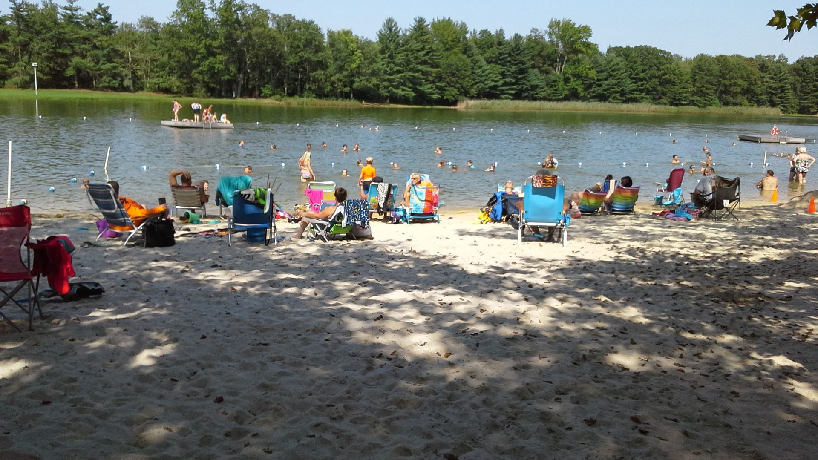
Gate Checker and Lifeguard Application Form
Are you looking for seasonal work, something to fill your summer? The Club is looking for Gate Checkers and Lifeguards for the 2023 Lake Season. The season runs from Memorial Day to Labor Day (weekends only until school is out).
We prefer gate checkers to be members or children of members.
- Lifeguard Applicants - You do not need to be a member of the Club for consideration.
- Note: Weekends and Holidays are the busiest time at the Lake. Please consider your summer availability when applying as we need the most coverage at that time.
- Gate Checker Requirements: Minimum age of 15 through senior citizens.
All ages 15 and older are encouraged to apply.
- Lifeguards Requirements: Minimum age of 16 with proper certifications (dark water training will be available at Club).
- Please send application (attachment below) or for questions contact:
Brian Kamens: : bekamens@gmail.com
Salem County Sportsmen’s Club
PO Box 130
Deepwater, NJ 08023-0130
OR

- Applicants may drop off at the Club Office, attention Brian Kamens, Lake Chairman.
- Application must be submitted by March 31, 2023. All applicants will be contacted by the second week of April.
- Gate Checker and Lifeguard Application Form

SCSC OFFICE UPDATES

From the Desk of Chrissy Jones, Office Secretary
and
Kathy Del-Signore, per- diem office assistant.

2022 Regular/Active Member Dues: $248.40. 2022 Retiree Member Dues: $134.55.
SCSC Mailing Address:
Salem County Sportsmen's Club, PO Box 130, Deepwater, NJ 08023

Office Ph: (856) 299-5588. Office E-mail: office@scsportsmensclub.org Webpage: www.scsportsmensclub.org/

SCSC Locator for 9-1-1 & Map Directions: 273 Wiley Road, U.S Rt 40, Carneys Point, New Jersey. 08069
Club Office Hours.
Monday - 10:00am - 2:00pm
Tuesday - 10:00am - 2:00pm
Wednesday - 4:00pm - 8:00pm
Thursday - 10:00am - 2:00pm
Friday - 10:00am - 2:00pm

Bar Hours
Wednesday - 5:00pm - 10:00pm
Friday - 5:00pm - 10:00pm
Saturday - 1:00pm - 8:00pm
Sunday - 1:00pm - 8:00pm
If arriving two hours before closing time, please call ahead to the Bar (856-514-2257).

CLUB RENTALS INFORMATION, Al Wood, House chairman
- Members should contact Chrissy Jones, office secretary, 856-299-5588 or email office@scsportsmensclub.org to initiate an indoor or outdoor Club rental, and for information on cost, date availability, and other logistics.

SAVE THE DATES

Canada Fishing Trip
- Dates: July 22nd to the 28th.
- Location: Dorval Lodge in Quebec Canada
- Logistics: Registration and deposits through the office. Members may bring guests who are not SCSC members.
- Next meeting: APRIL, date to be announced. Stay tuned for more info.
- Questions, contact John Dyer.

Cigar Nite
- Date/Time: April 7th, 2023, 7:30pm
- Logistics: Get 2 cigars and 1 Drink. Enjoy a night of fellowship; Corn hole and the fire for ambience.
- Cost: $25 per ticket. Tickets available in the office.
- Questions: Contact John Dyer. Member’s guests are welcomed.

Easter Sunrise Services & Breakfast

- Sunday, April 9, 2023. Services 7:30 am at Clubhouse, rain or shine.
- Pastor Dan Lapp, Club Chaplain presiding.
- Attendees are invited to breakfast in the Clubhouse following the service.

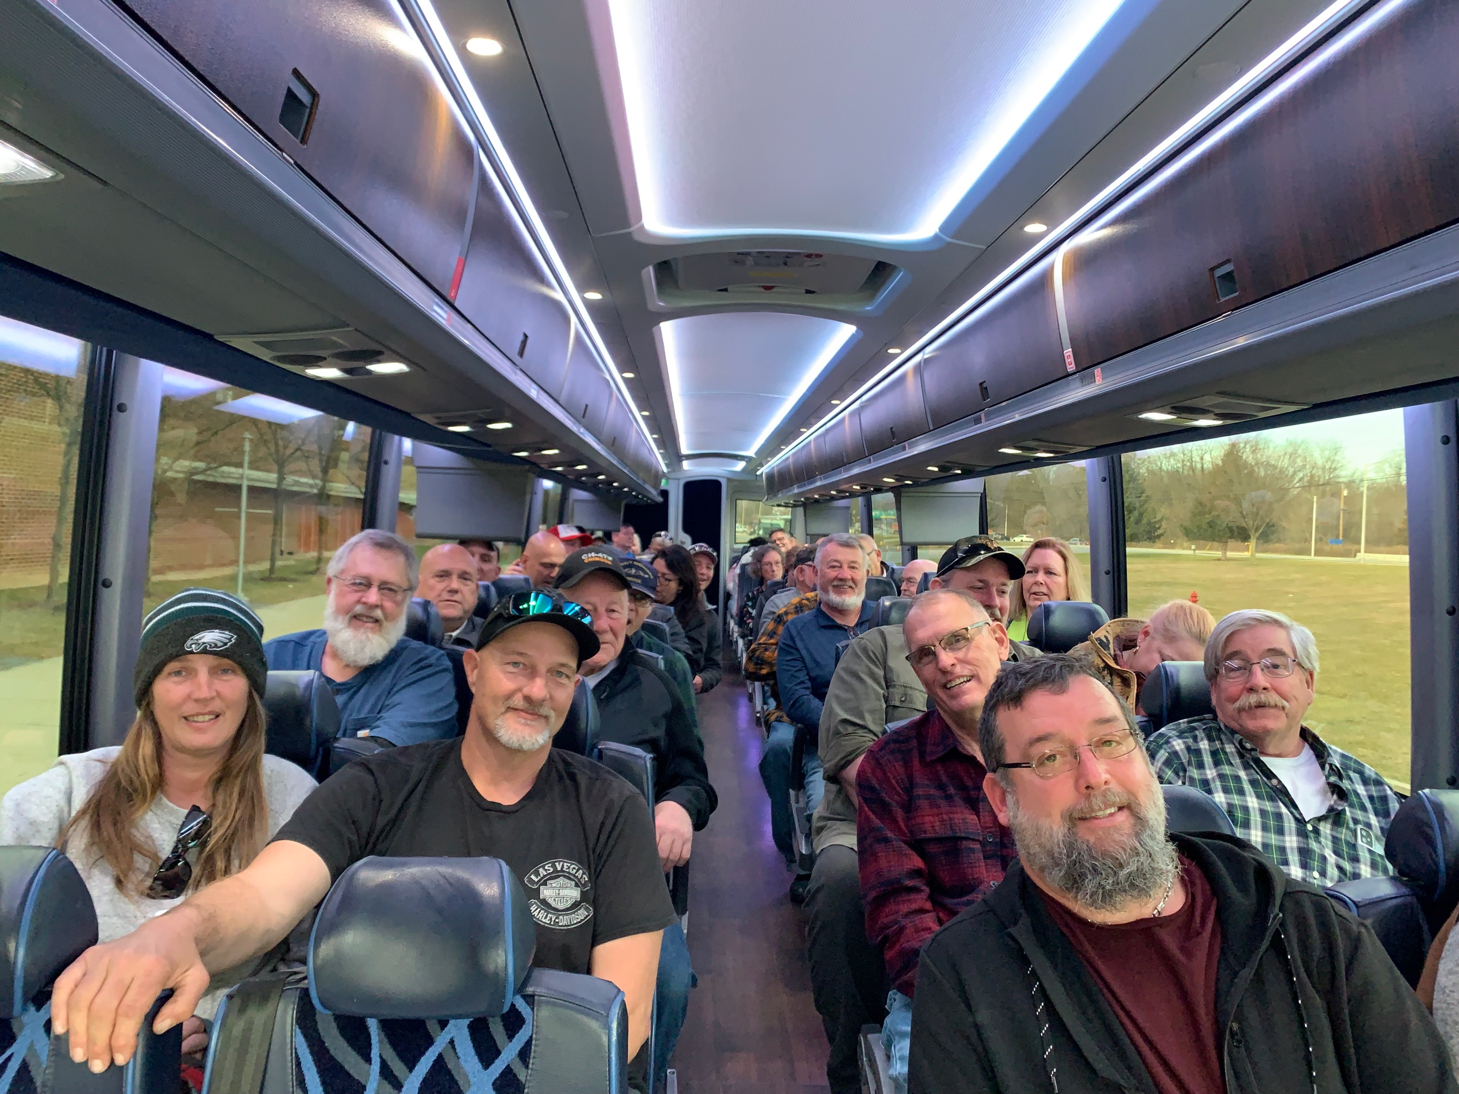
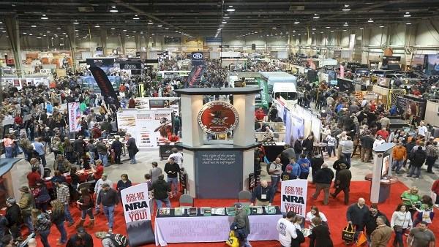
SCSC Attends 2023 Great American Outdoor Show

On February 8th, 41 members traveled to the largest outdoor show in the world in Harrisburg, PA, the Great American Outdoor Show (GAOS). The Club has sponsored this annual member day trip for over 10 years. Sponsored by the National Rifle Association (NRA) the show included nine halls of guns, archery, fishing tackle, tree stands, boats, RV’s, trucks, outdoor tools, ammunition, outdoor clothing, firearm accessories & parts, sporting knives, dock water dog leaping & retrieving competitions, 400 outfitters and boat captains from around the world, and outdoor celebrities, seminars, and events. For outdoor men and women, the GAOS generally has the latest and greatest of everything of interest and purchase including valuable training and information.

To attend the GAOS, costs are approximately $55pp for round trip bus fare, a breakfast stop, show tickets, on-board beverages, and a light supper back at the Club. Time at show is approximately 5 hours and total time for trip is 12 hours. As always, the trip continues to be a relaxing, enjoyable day for the outdoor men and women who attended the event. Thanks to Joe Lubrano kitchen chairman, Ms. Lubrano, and Al Giumetti for serving a a wonderful return supper. Also, thanks to Bar Chairman Bill Ronn for providing on-board beverages. The trip is sponsored by the SCSC Board of Directors and coordinated by Chrissy Jones, office secretary and historian Ev Sparks. Transportation is provided by Delaware Express. This year’s (very) professional and outstanding bus driver was Clark Pyewell.

As always, “a good time was had by all”.

SAVE THE DATE: Next year’s GAOS - February 2024.

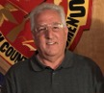
75 Years of Volunteering, 1947 – 2022
Stu Schermerhorn

VOLUNTEERISM is the lifeblood of our Club

TUESDAY VOLUNTEERS ATTEND FIRST AID CLASS
STOP THE BLEED & TOURNAQUETS

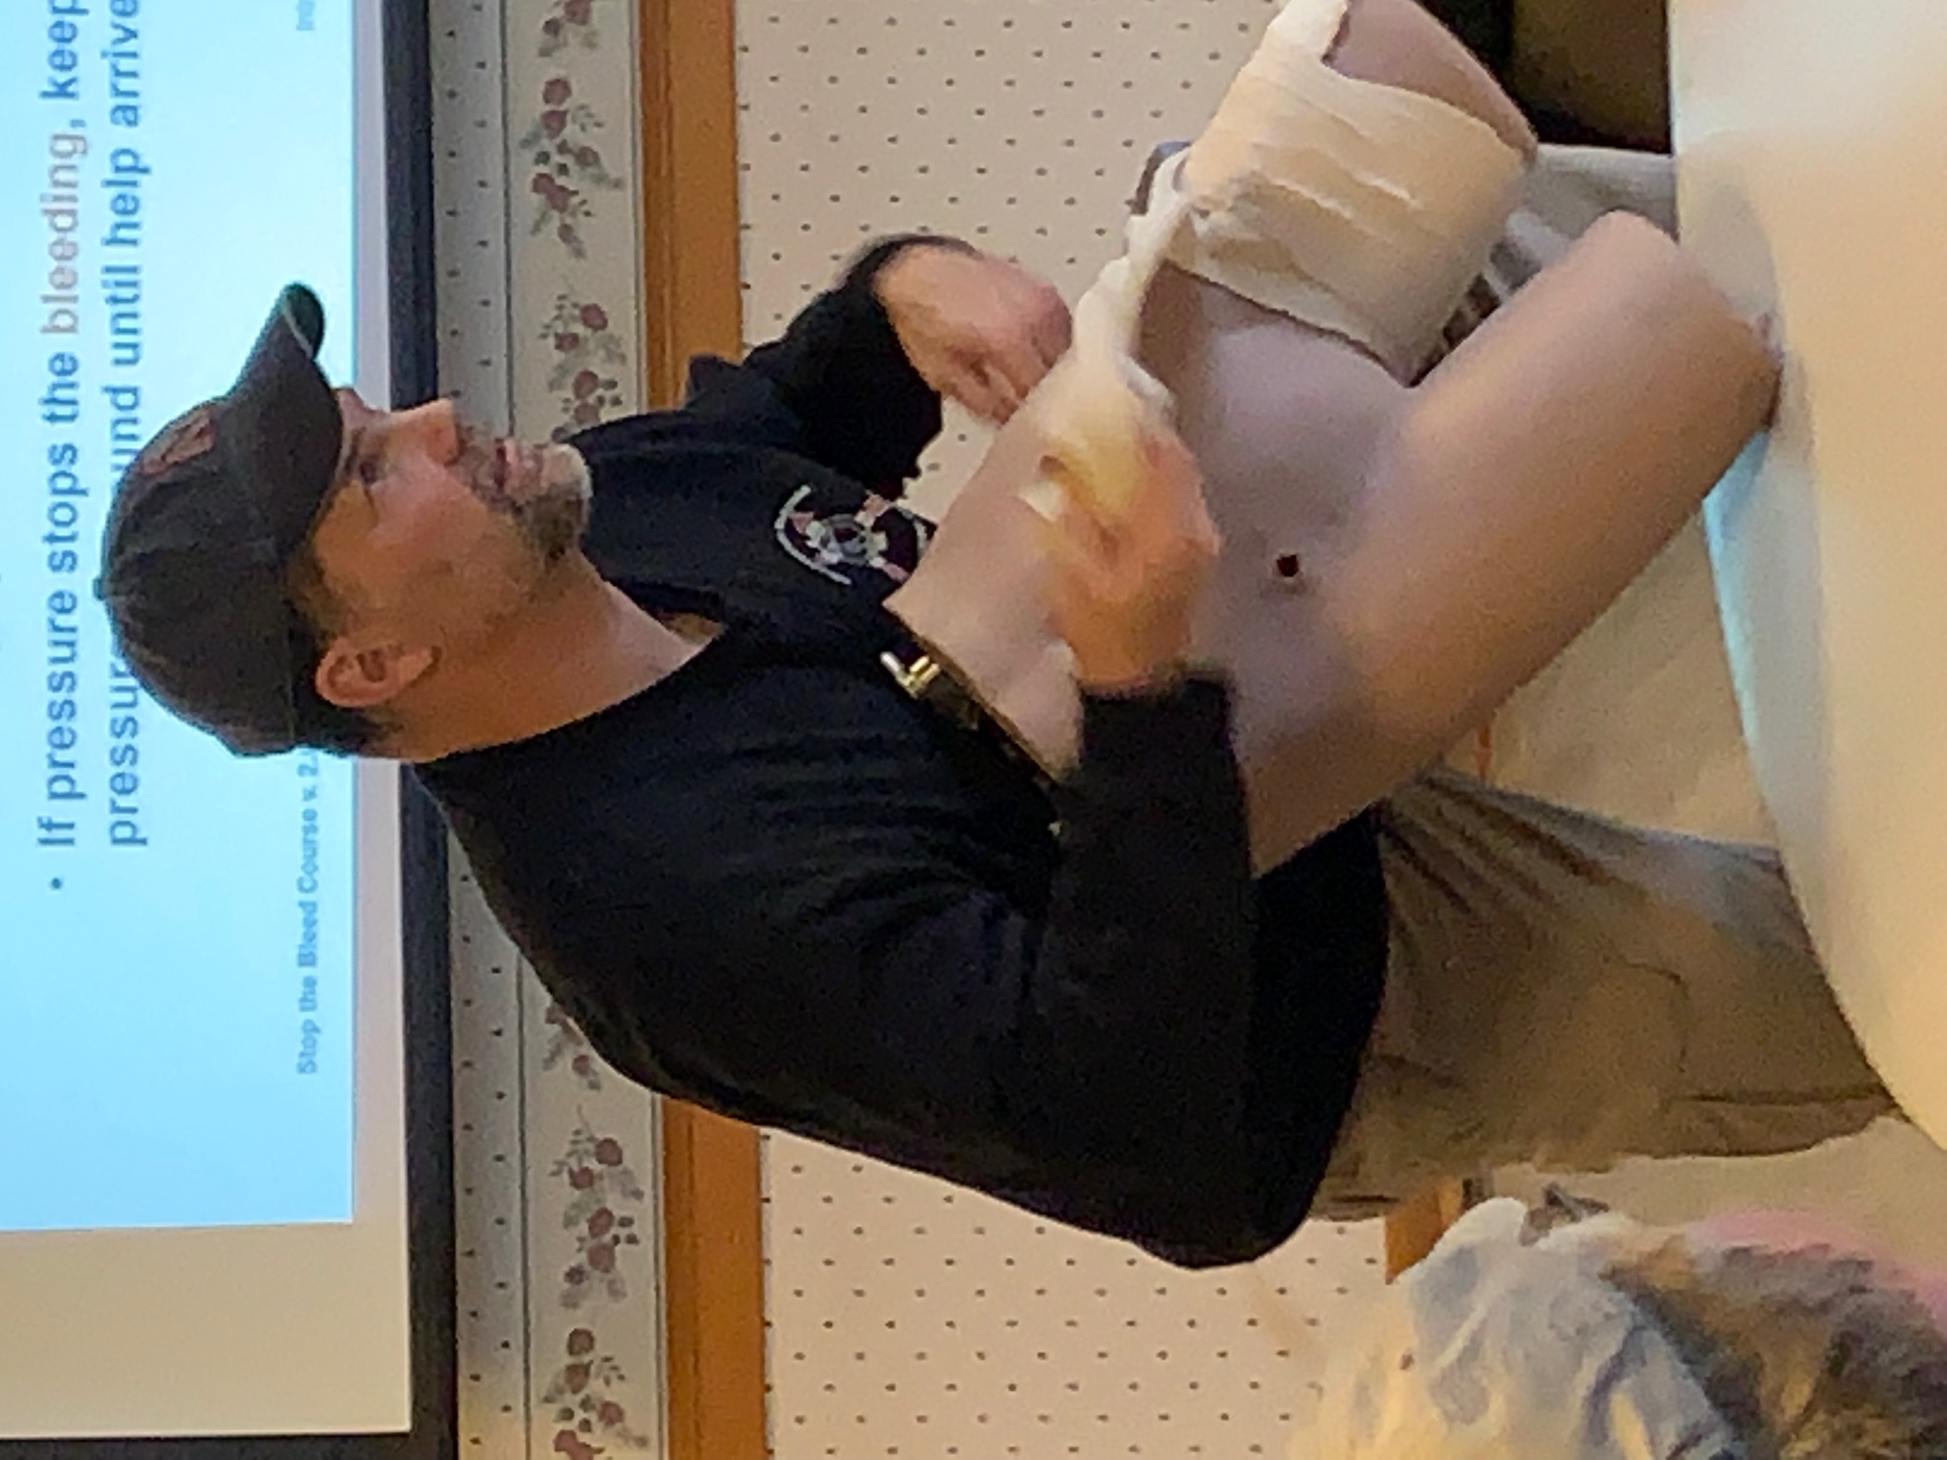
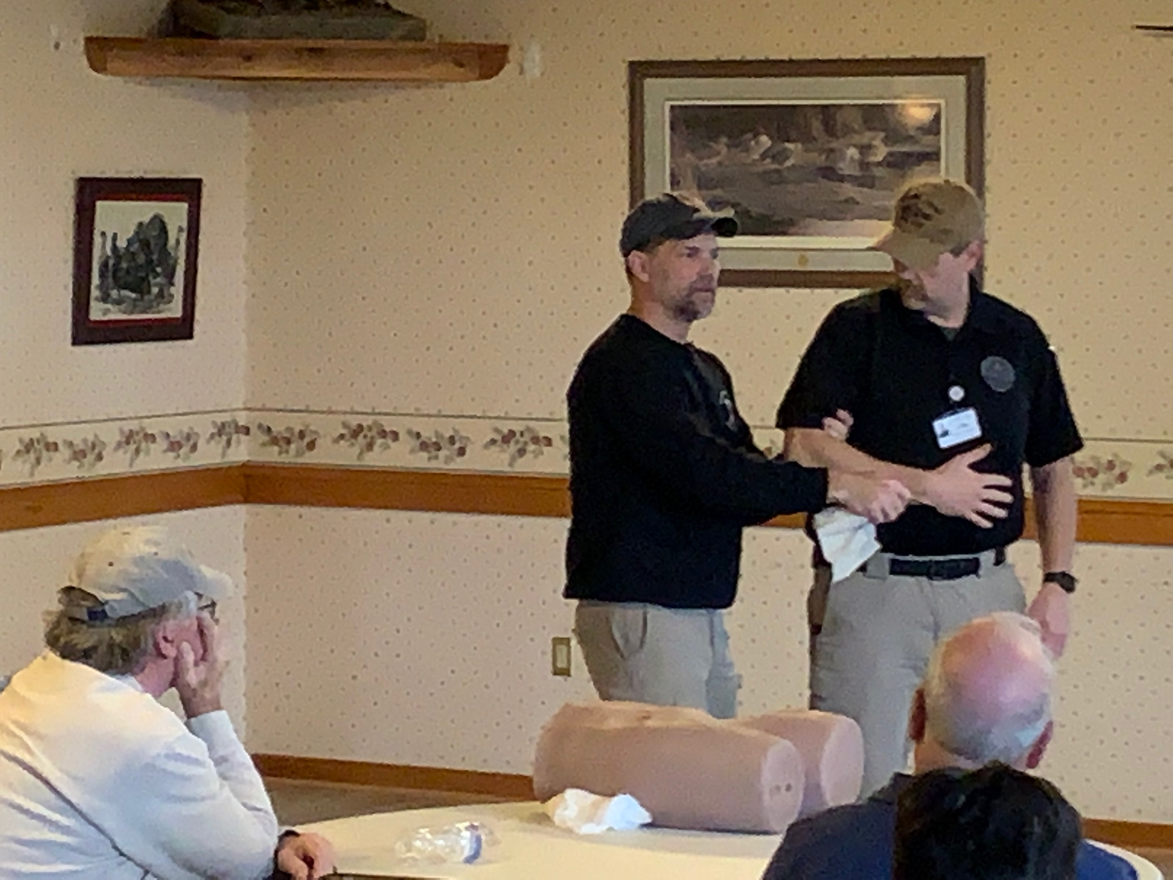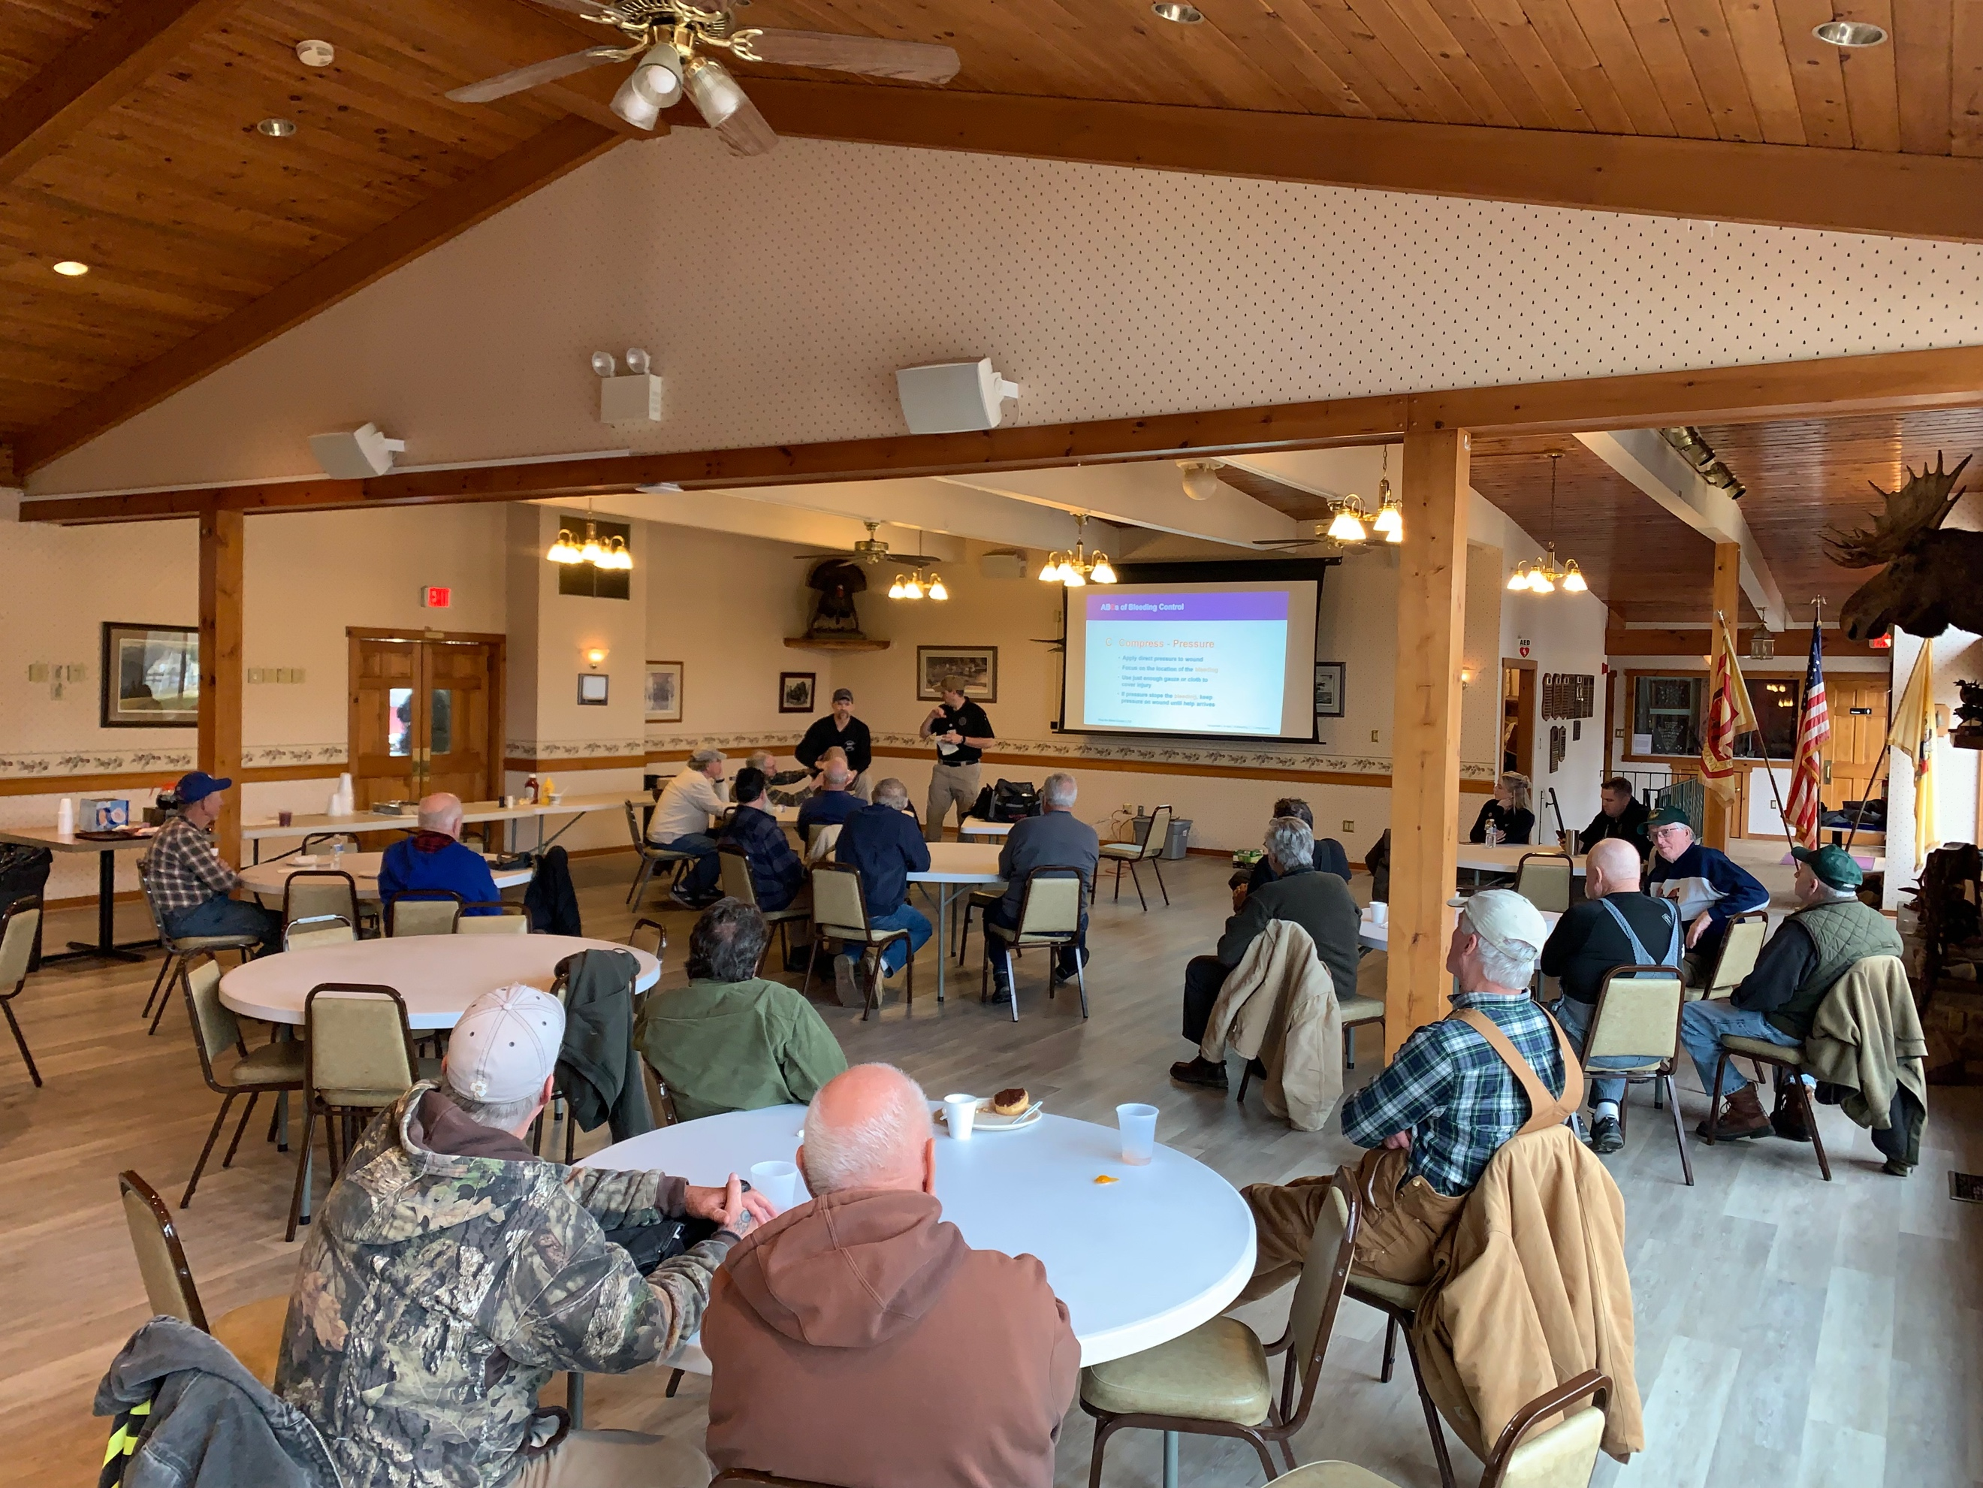
Thank you to member and Army medic Corey Terry for providing valuable life safety first aid training to the Tuesday volunteers on February 7. Corey has offered his expertise to offer other life safety training to the Club in the future. His vast experience and training as an Army veteran were very well received as we look forward to future training in the future.

The Club thanks Corey Terry for his military service to our country and as a Club as a volunteer!

Enjoy the Club, your Club!

Stu Schermerhorn & the SCSC Volunteers

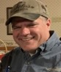
CLUB RANGE NEWS
Ron Ayres, Range Director

Thank you to our members for your safe conduct on the ranges and strictly adhering to our range rules. The posted range rules are necessary and are to be followed without exception. If you are not badged or have questions, do not shoot on SCSC ranges until you have your questions answered by a range officer, a badged knowledgeable shooter, the SCSC caretaker, Tom Del-Signore, 609-420-2524 or myself, at rmayres@verizon.net. The ranges have been busy this Fall as usual. Be safe, be courteous, and enjoy your time on the ranges.
Range Badges
Anyone seeking a Range Badge need have their name on the waiting list. We will get a class scheduled as soon as possible.
Range Badges are REQUIRED to use the ranges. Remember to always have your badge with you and displayed where someone can always see it while using the ranges. Contact the office to get on the waiting list.

Instructional Classes
Anyone looking to attend an upcoming Basic Rifle, Pistol, Shotgun or RSO class needs to contact the office to get their name on the list. The Basic Pistol classes can be used to obtain your NJ carry permits as well as going on to be certified instructors. Class will be scheduled on an as needed basis.

Trap and Skeet
Trap to resume in the Spring, opening date to be announced. Skeet still shooting on Sunday mornings.

Archery:
SAM PIERMAN was appointed in October to the board of director filling the unexpired term of John Spiewak. Sam has contributed greatly to the archery sports at the Club and is assigned to the archery ranges as a new director. The Club thanks John Spiewak for his service to the Club as a director and for his work on the Club’s archery ranges.

Enjoy the ranges, be safe, shoot straight on approved targets. Ron Ayres

FRIENDS OF NATIONAL RIFLE ASSOCIATION March 4, 2023
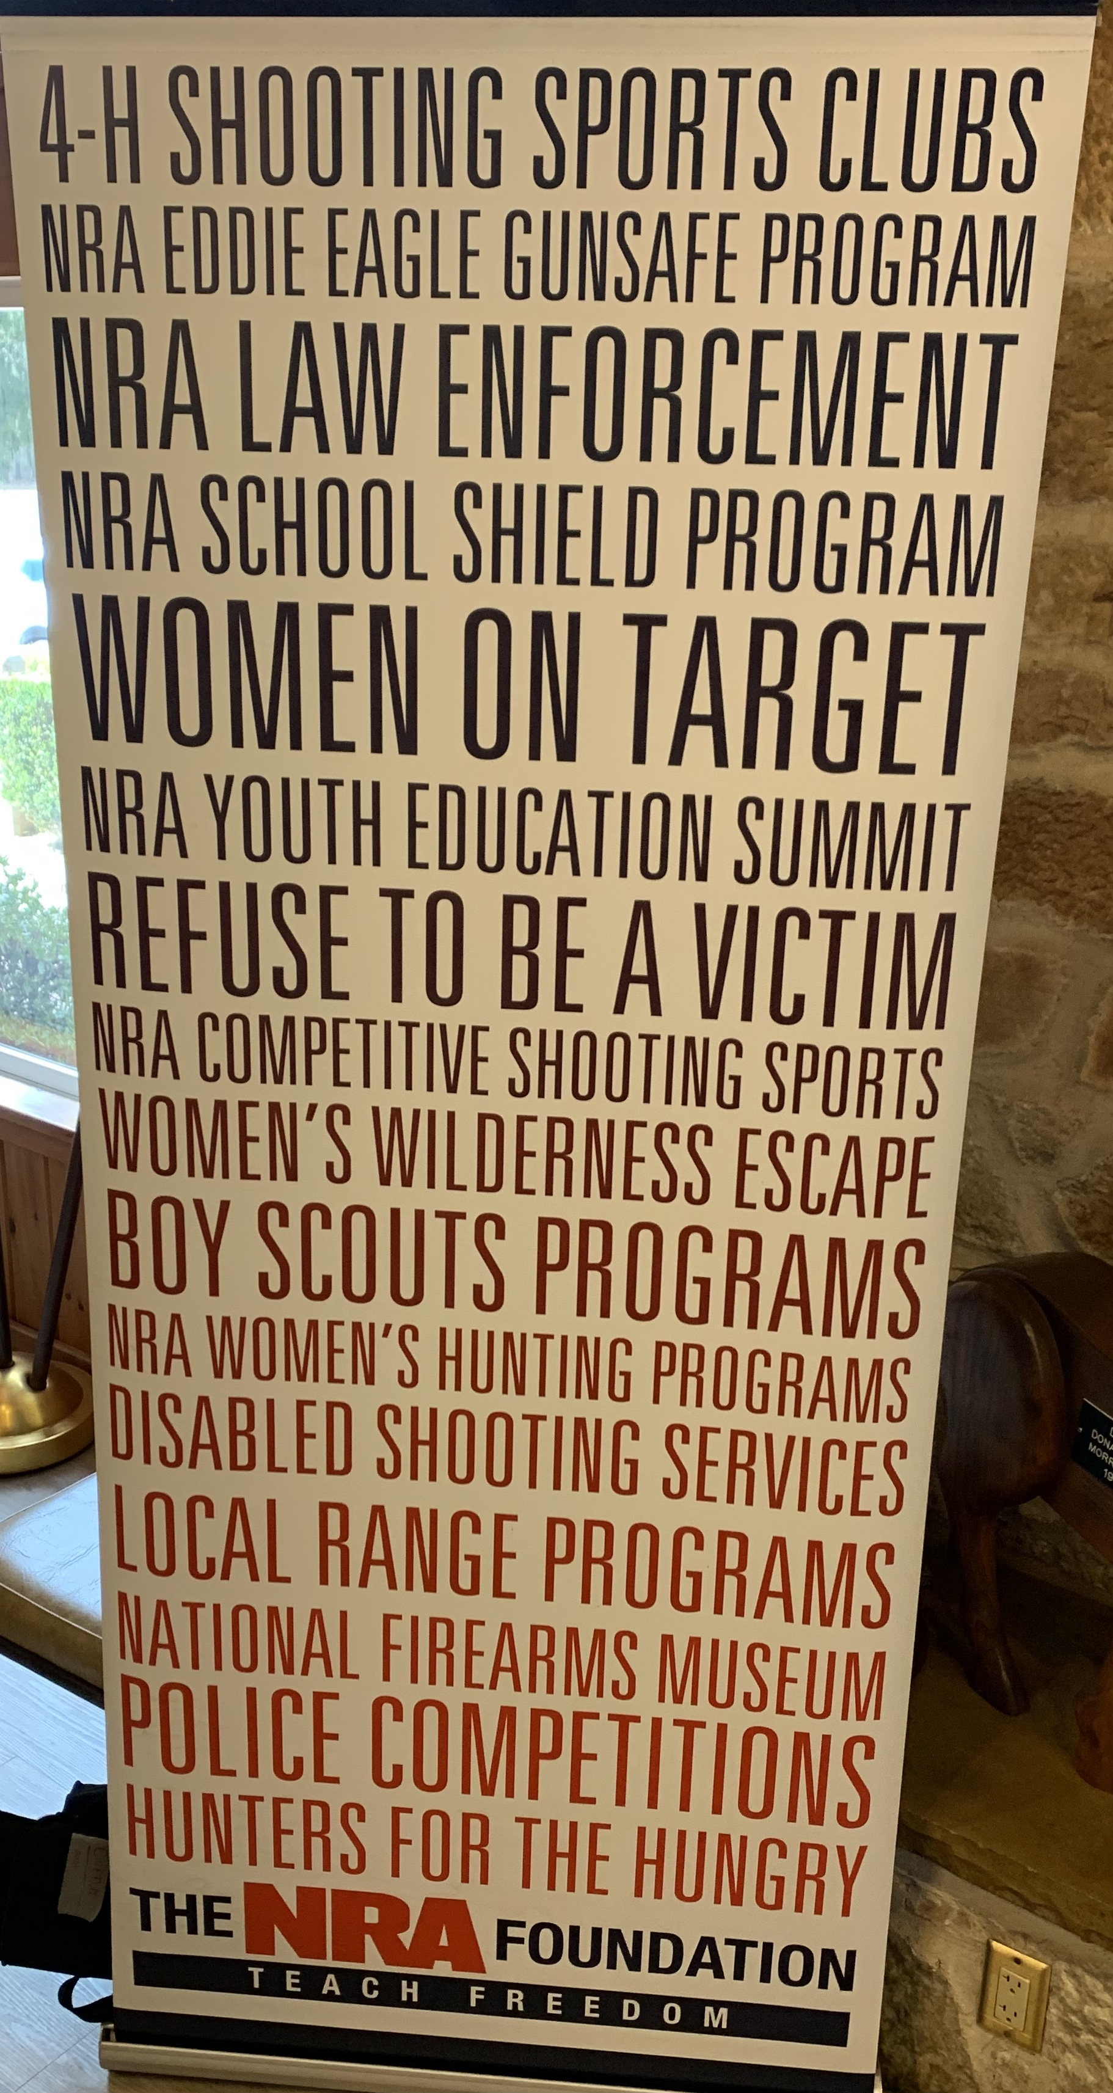
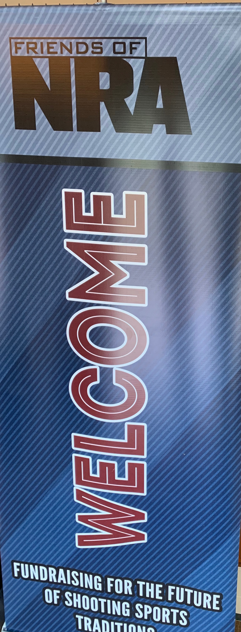
The Club hosted the NRA and Field Representative Gregory Nyce to our annual FNRA game dinner and fund raiser for the NRA. Approximately 90 supporter of the NRA and FRNA shooting education activities attended the event. Club volunteers, Ron Ayres, Dave Cesarano, Mert & Marissa Coles, Tom & Kathy DelSignore, Sam Pierman, Mike Yucis, Anthony Kuzmunick, and Doug Craft.

The night included a great social hour, silent auctions, drawings and a live auction by Salem County’s Auctioneer Grant Harris. The trip of a lifetime for an African Safari and hunt was conducted. The winning bid for 1 week for two was won for $1500.

As always, the SCSC Range Committee and the NRA hosted a very successful, fun FNRA annual fund raiser for the shooting sports.

As always, “a good time was had by all” who attended!

FNRA NIGHT, March 4, 2023
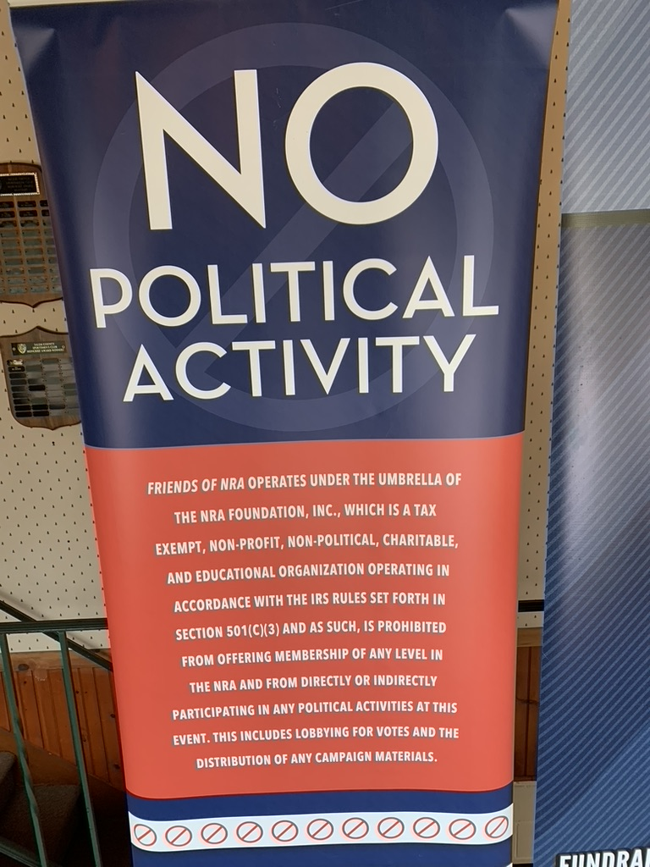
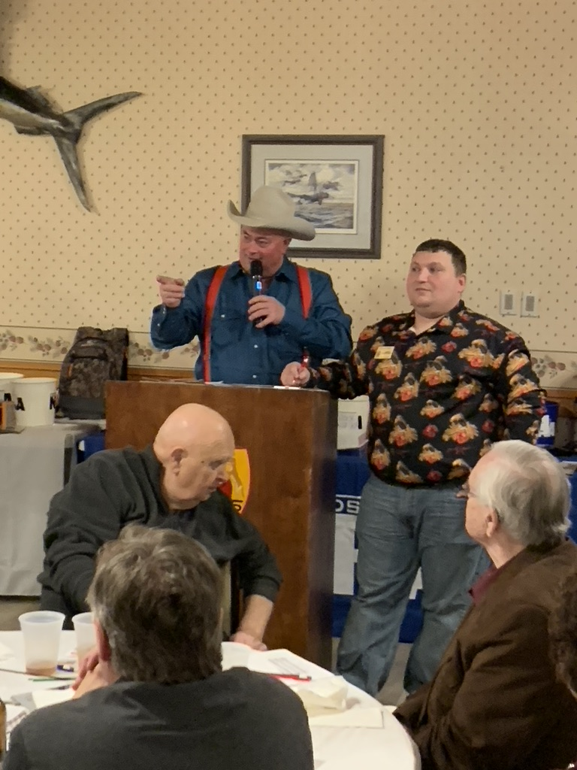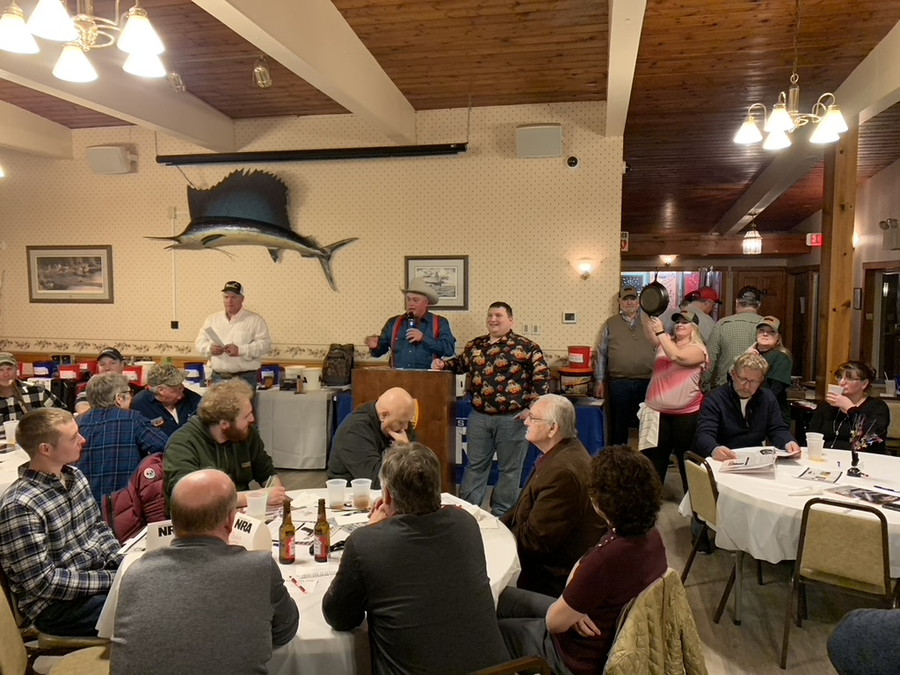

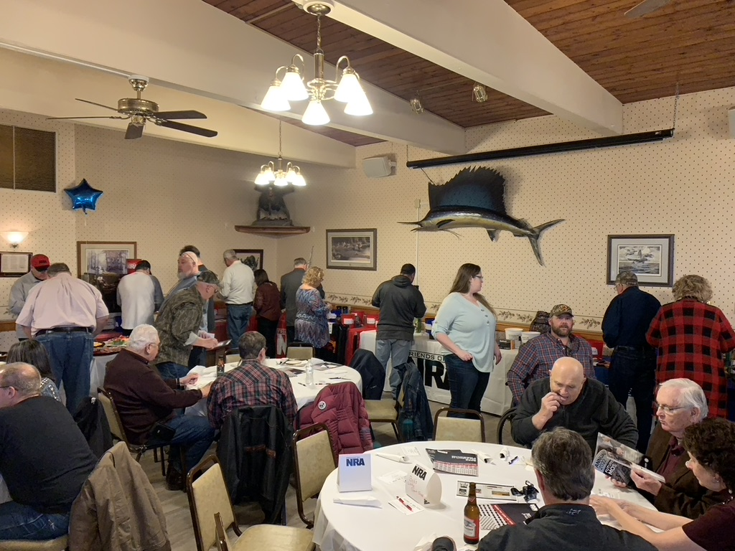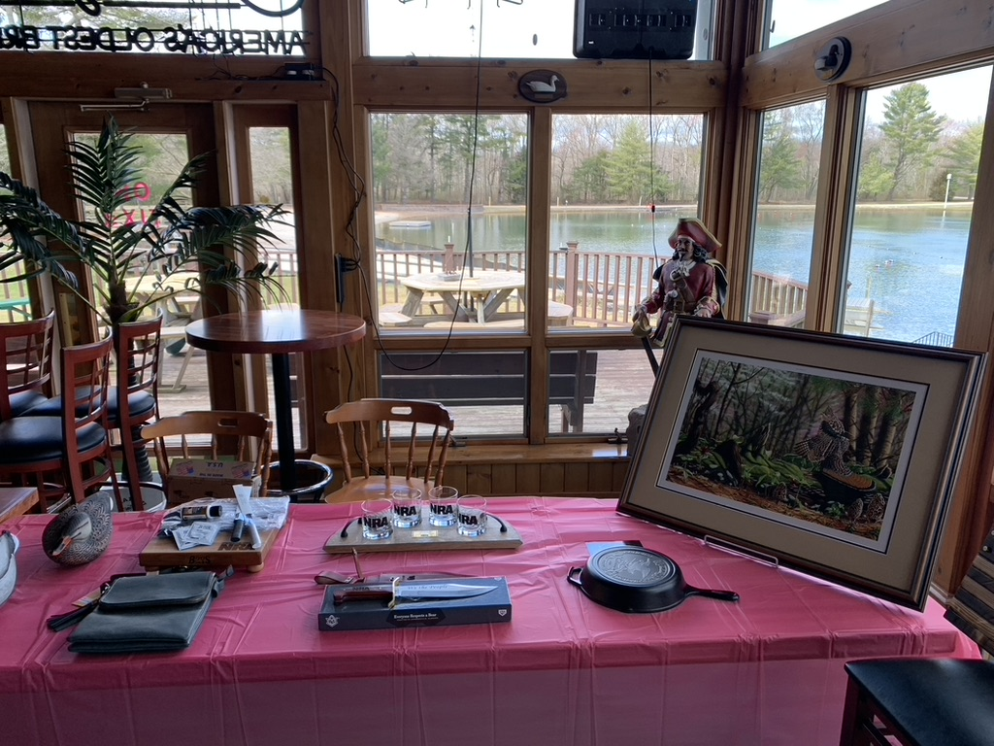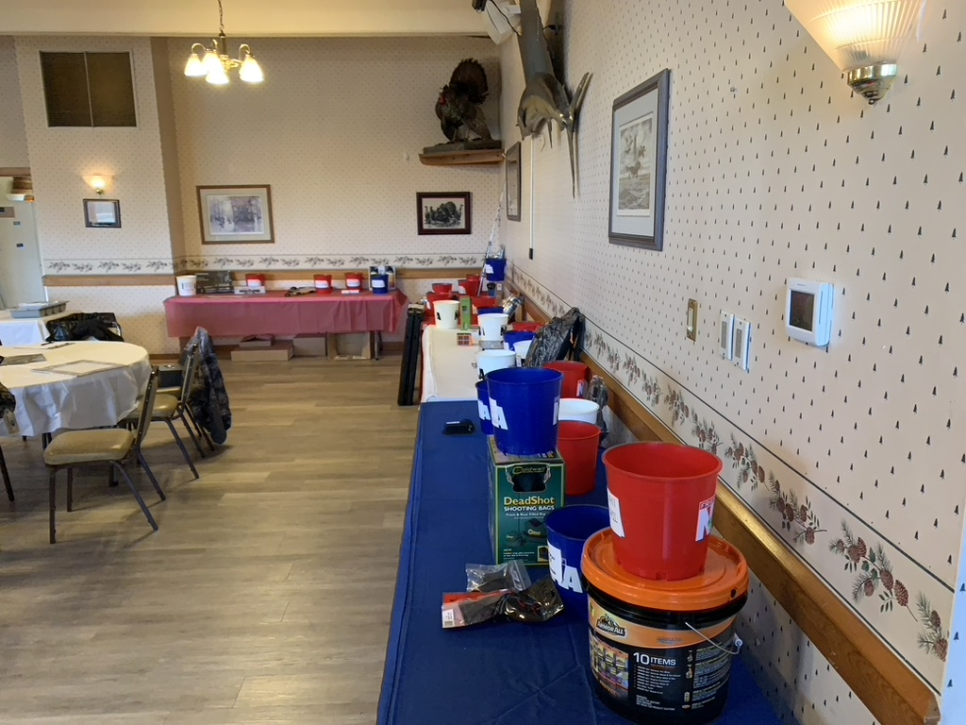

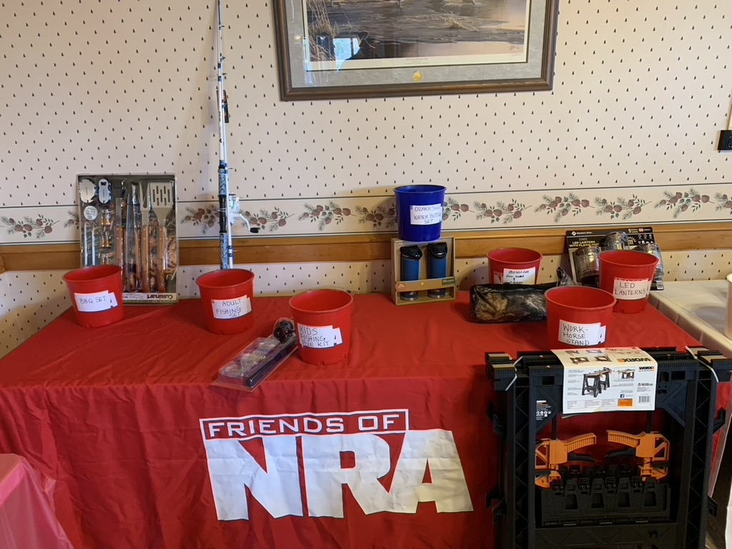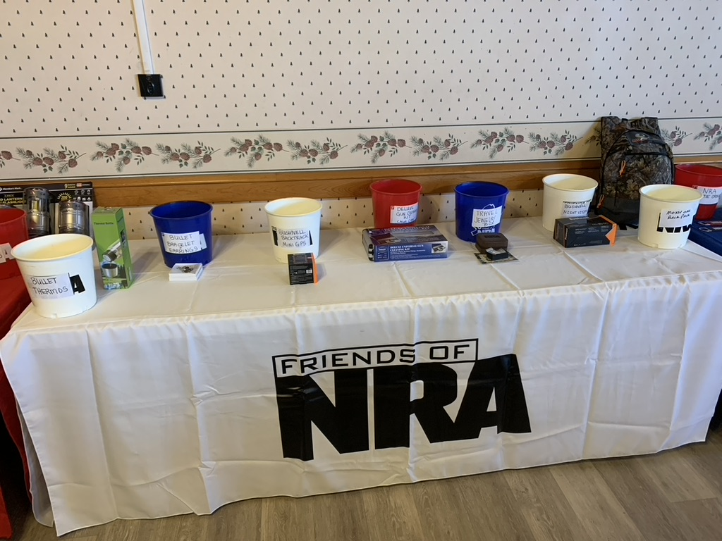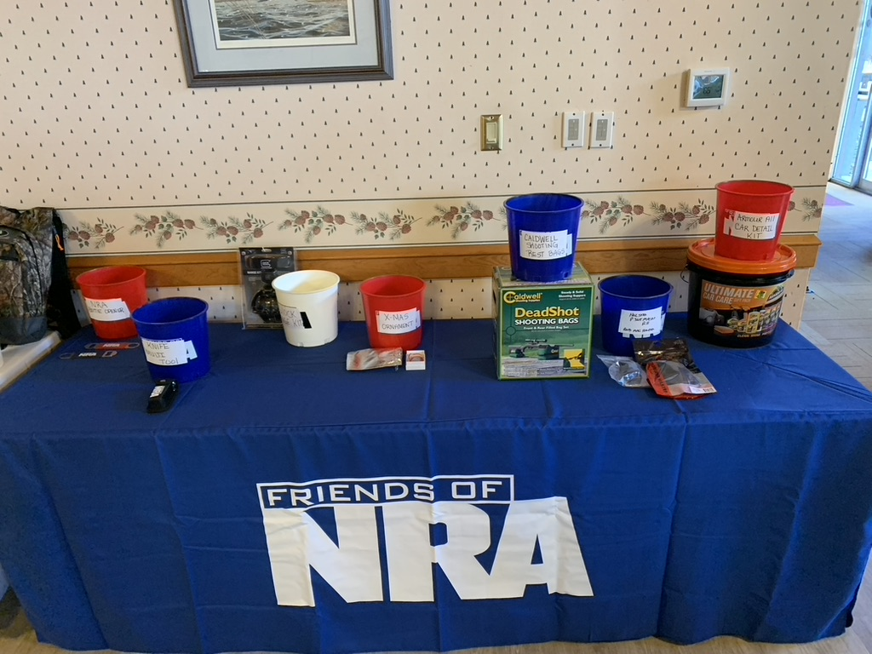

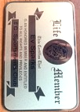
Parting Notes

By Ev Sparks

SCSC Newsletter Editor & Historian

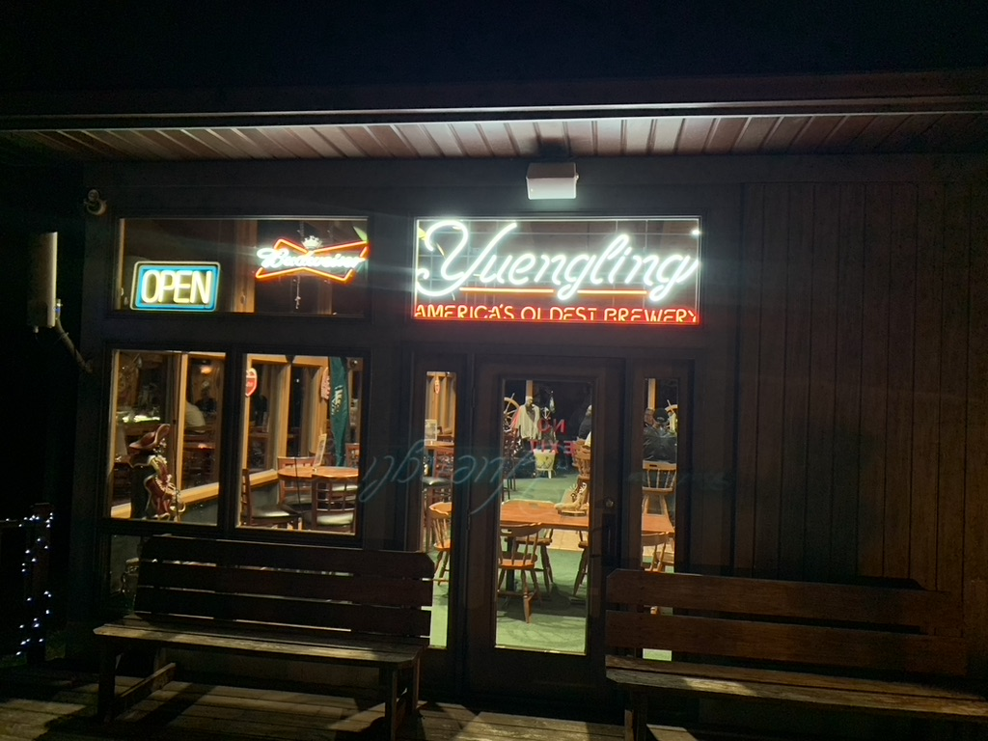
DIRECTORS IMPROVING SCSC AND MAKING THEIR MARK IN ASSIGNMENTS - BILL RONN

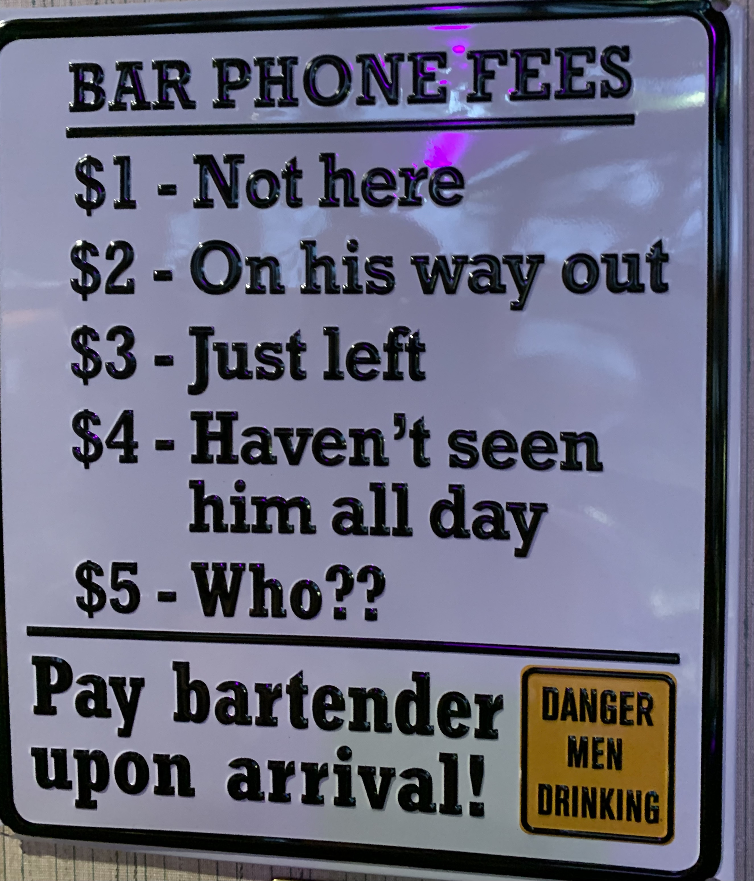
Throughout the history of the Club, directors in various assignments have continually improved and upgraded improvements of their predecessors in the same assignment. This newsletter is dedicated to Bill Ronn and the contributions and improvements he has implemented in assignment in SCSC food and beverage services. At the beginning of Bill’s assignment, he had installed a commercial stainless steel 3 compartment sink. He then added a new commercial stove to the kitchen. As part of laminating the floor of the main room, the kitchen floor was also included to make cleaning the kitchen much easier. Bill added a “hot cabinet” for keeping food temperatures safe when preparing large trays for larger groups. The main lounge and bar area now has high top tables and chairs (replacing the original furniture decades old – still repurposed for use elsewhere). The most recent additions include the addition of signage that add to the welcoming nature of the Club for members. Bill comes from a food & beverage background and has brought his experience and expertise to improving the Club’s food and beverage service for its members. Bill is now serving as Club vice president and bar chairman. Well done Bill and thank you for your service and contributions to the Club.

Shown below: 2023 Directors and 1949 Directors at work.
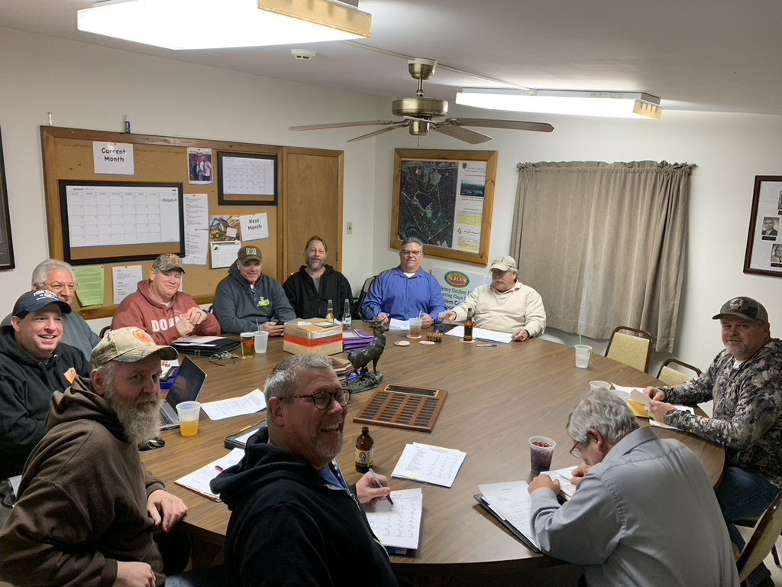
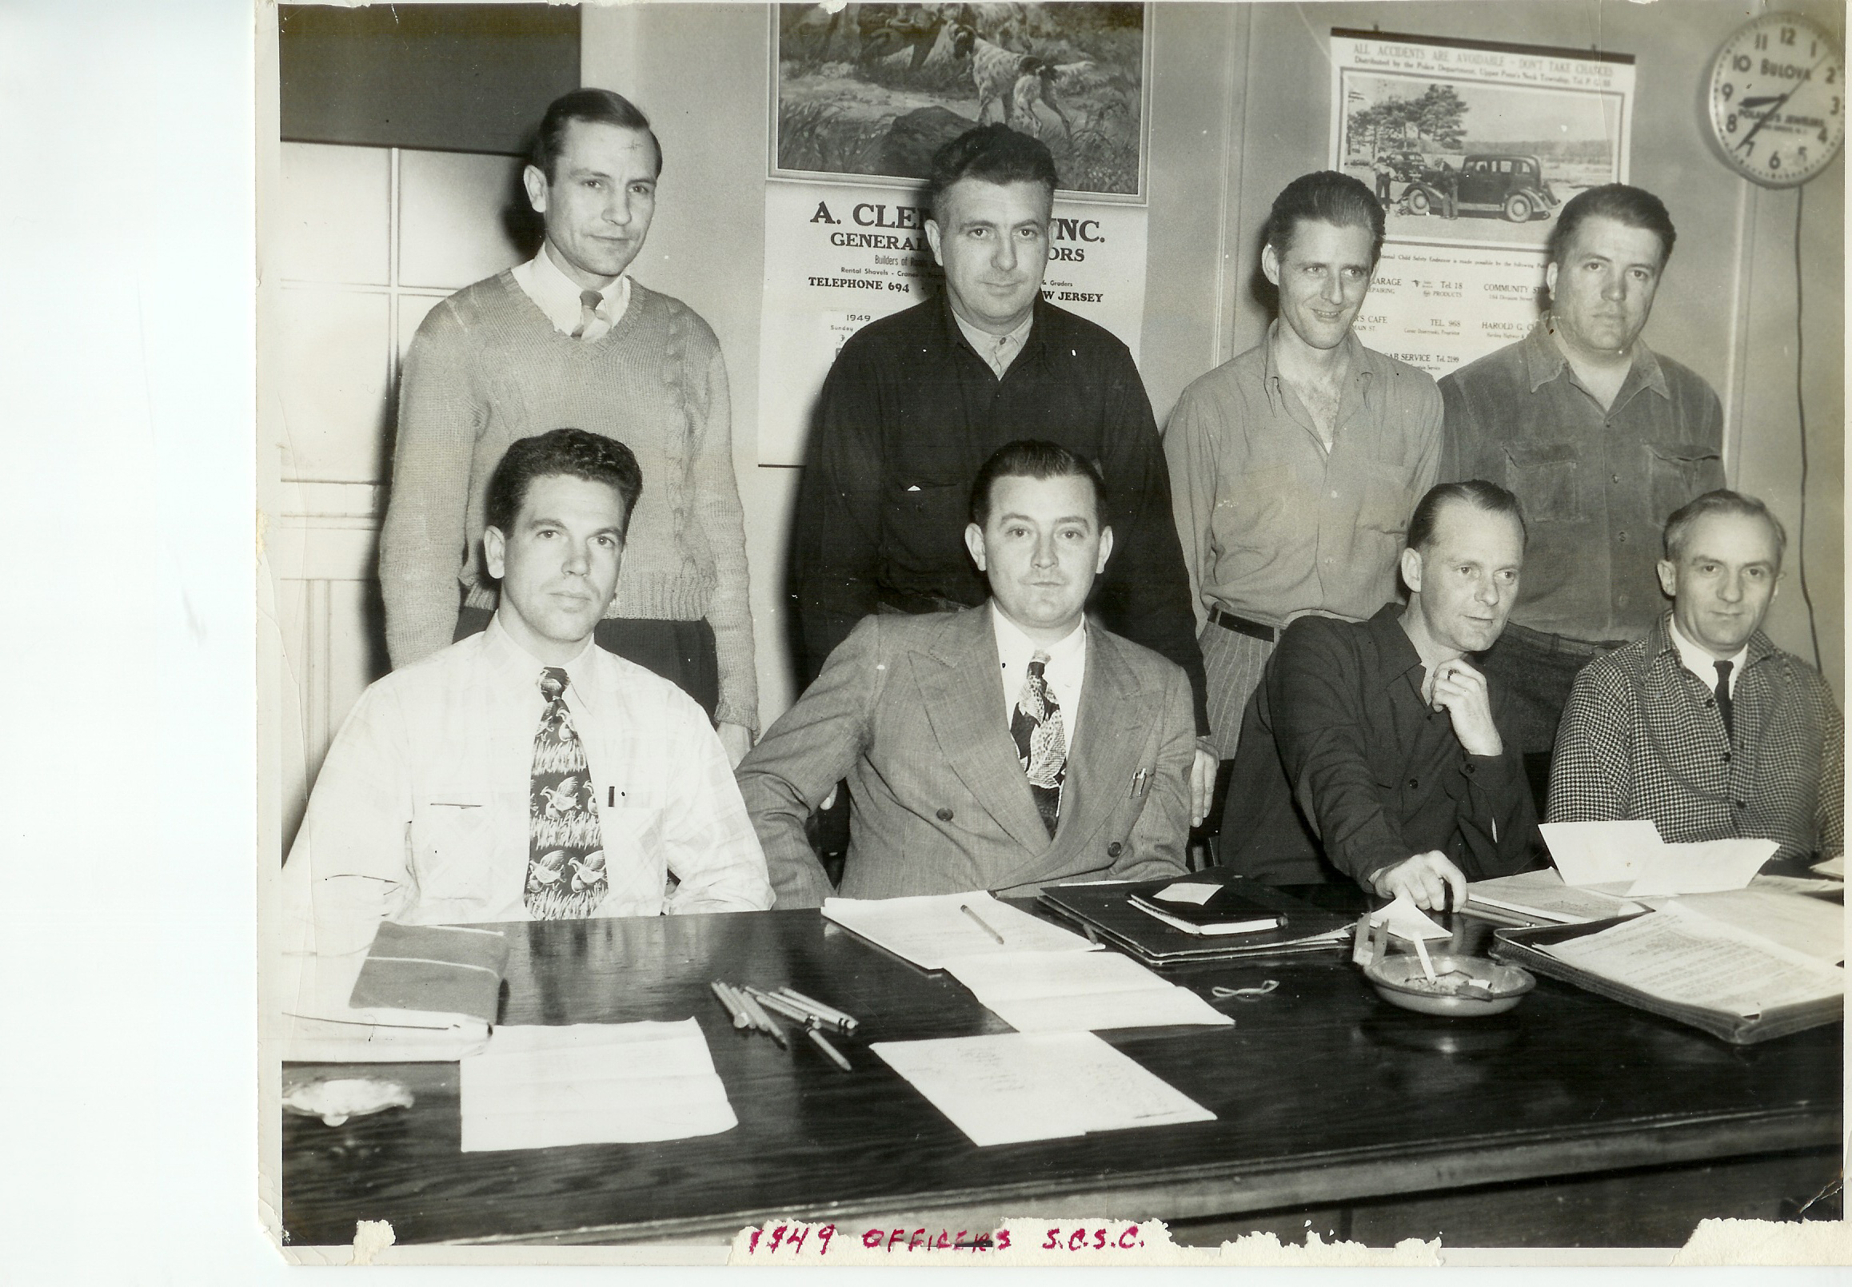
As they have over the last 76 years, Club directors meet formally as volunteers twice per month to perform the necessary work to advance the Club’s mission. During the month additional volunteer hours are dedicated to keeping the Club and all its moving part running smoothly. To be a director both leadership skills and tactical skills are necessary for planning and hands-on work individually and as part of larger project work parties.
1949 BOARD OF DIRECTORS
Back Row L – R: Sam Cup, Charlie Burkentine, Max Young, Pete Blyler,
Front Row L-R: Bill Talley, Bill Adams, Glen Young, Payton Kilburn

EDITORS NOTE:

WHERE ELSE EXCEPT AT THE SCSC!
Where else except at the SCSC, near your home, would we be able to undertake so many outdoor activities? Where else can we hike, dog walk, fish, boat on two bodies of water, shoot, camp, picnic, entertain, archery shoot, support a wildlife preserve, conserve woodlands & wetlands, experience family time on 300 acres of outdoors and have a beautiful Clubhouse for indoor events – not many.
Enjoy and respect your Club, respect your co-members, and our 76th year of forward progress and development of our Club.

Submissions to the Lake Hudson News
All submittals are subject to review and inclusion by the editor and the BOD. Send by email in care of editor to scscoffice@scsportsmensclub.org. Copy may be submitted in writing to the SCSC office. The Lake Hudson News is the newsletter of Salem County Sportsmen Club named in recognition of Arthur “Moose” Hudson a founding member and first Club caretaker. The newsletter serves as a communication mechanism to members and as a historical record to document the continual progress and improvement of the Club’s mission and charter over its 75 years, 1947 – 2022 and beyond.

SCSC Communications Notice:
The club e-mails and official website are the only online source of official club information.
The Salem County Sportsmen's Club does not own, operate, or otherwise manage any social media accounts (e.g., Facebook, Instagram, Twitter, etc.). Club members that rely on any such social media account for club activities, or any other reason, do so at their own risk.

